**Ideation Phase**

**Define the Problem Statements**

|  |  |
| --- | --- |
| Date | 27 September 2022 |
| Project Name | Project – Personal Expense Tracker |
| Maximum Marks | 2 Marks |

**Customer Problem Statement Template:**

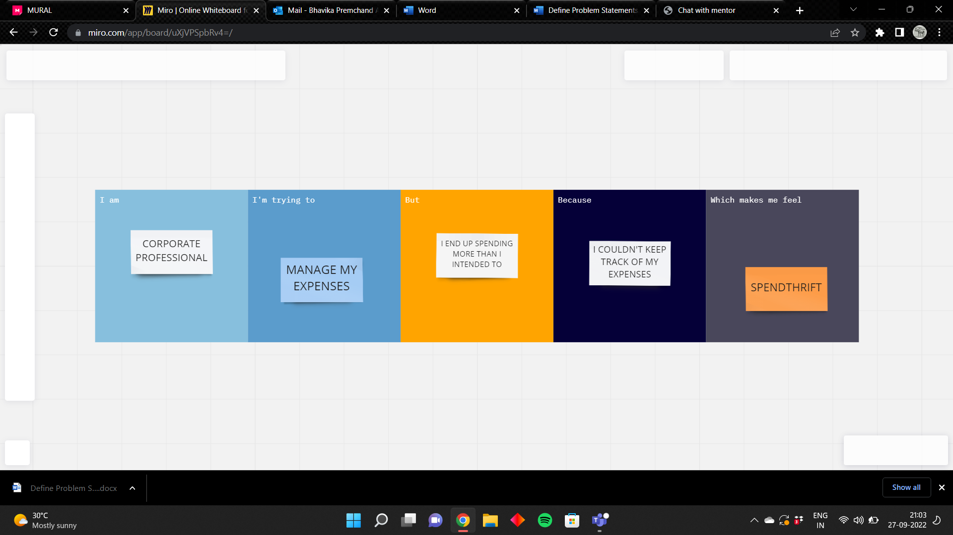

|  |  |  |  |  |  |
| --- | --- | --- | --- | --- | --- |
| **Problem Statement (PS)** | **I am (Customer)** | **I’m trying to** | **But** | **Because** | **Which makes me feel** |
| PS-1 | Corporate professional | Manage my expenses | I end up spending more than i intended to | I couldn’t keep track of my expenses | Spendthrift |
| PS-2 | Residential Student | Limit my spending | I can’t keep track of it | I have multiple small spendings and I am forgetful | Irresponsible |